PIPELINE AND NON-PIPELINE:

1)IMT2022530-H.Sanjeev

2)IMT2022059-Pudi.Kireeti

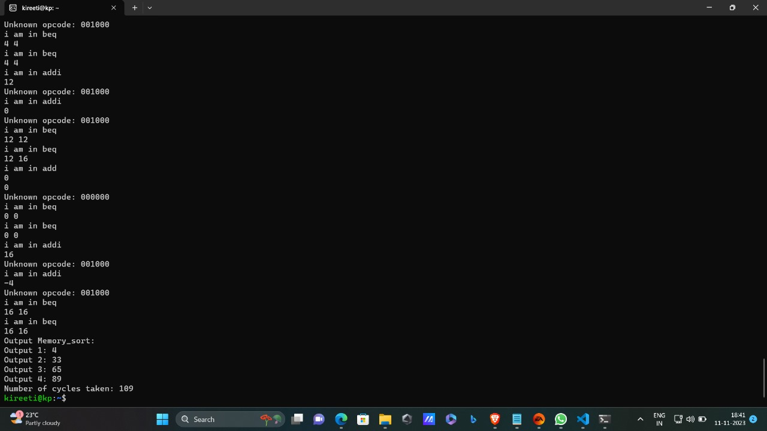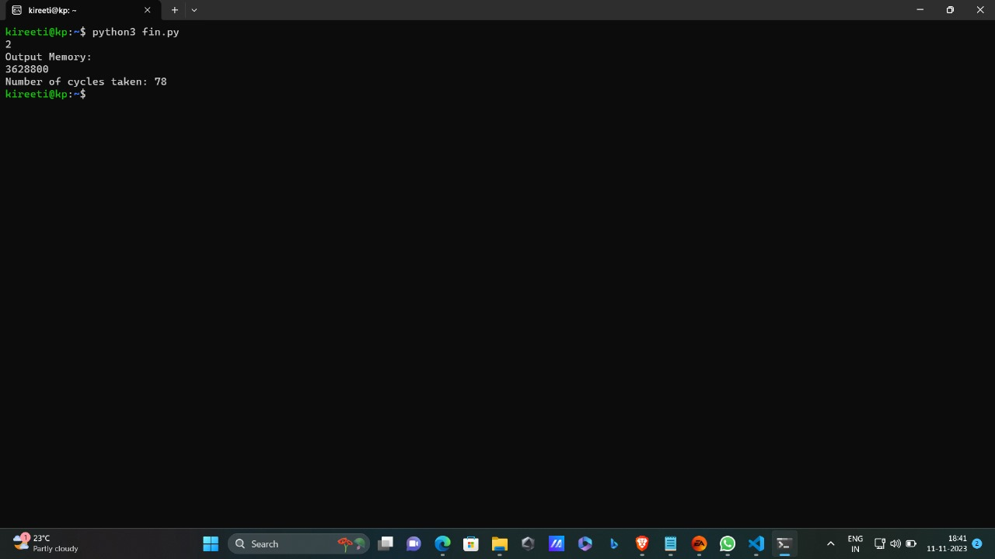

The above picture shows the output of the non-pipelined architecture for sorting and factorial.

What our code does is, it reads each instruction from our machine code of factorial and sorting, so our code divides the r,I,j type instructions and divides rs,rd,rt accordingly, and it verifies the opcode and decodes which instruction it is and does its respective work. It divides according to the opcodes and does the respective tasks and runs through the whole machine and does the same.

Now what we have done is we attached the code for factorial to that of sorting so it does both the works.

The factorial of a number is given in the code itself, we have hardcoded 11 to it in the machine code itself, but in the sorting part it is a user based module, we can give any input we want and it will sort those given numbers in sorting order and also gives the number of cycles it will take to do the respective task.

We made the program run in such a way that when we give the option 1 we do sorting and 2 is given as an option we do the factorial.

In the sort when we run the program we get output in such a way that we can visualize the steps that is how the program is running can be seen.

 "00000000000010100110000000100000",

            "00000000000010010111000000100000",

            "00000001110010010111000000100000",

            "00000001110010010111000000100000",

            "00000001110010010111000000100000",

            "00000001110010100111000000100000",

            "00000000000011100111100000100000",

            "00100001111011111111111111111100",

            "00010001100011100000000000010001",

            "00000000000010100110100000100000",

            "00010001101011010000000000000011",

            "00100001100011000000000000000100",

            "00100001111011111111111111111100",

            "00010001100011001111111111111010",

            "00010001101011111111111111111100",

            "10001101101110000000000000000100",

            "10001101101110010000000000000000",

            "00000011000110011100100000101010",

            "00100011001110011111111111111111",

            "00010011001000000000000000000010",

            "00100001101011010000000000000100",

            "00010001101011011111111111111000",

            "10001101101110010000000000000000",

            "10101101101110010000000000000100",

            "10101101101110000000000000000000",

            "00010011001110011111111111111010"

This is the machine code for the sorting.

 "00100100000011000000000000000000", "00100100000010000000000000000001",

            "00100100000011100000000000000000", "00100001100011000000000000000001",

            "00100001000010000000000000001010", "00100001110011100000000000000001",

            "00010001000011100000000000000110", "00000001100000000110000000100000",

            "00100001000010001111111111111111", "00000001100000000110000000100000",

            "01110001100010000110000000000010", "00100001000010000000000000000000",

            "00010001000010001111111111111001", "00100001111011110000000000000000"

This is the machine code for factorial.

As far as the pipeline code is considered, its runs without any errors but doesnot give any output.

In the pipeline we have tried to include the hazards, tried for forwarding and make it run as a pipeline.